

Programming Web/Cloud/Mobile

# Lab 1 Assignment

Team Members: Pragathi Thammaneni Sridevi Mallipudi
LAB -1 Assignment

Introduction:
This Lab assignment deals with the the basic web technologies HTML, CSS ,JavaScript with responsive web design(RWD) .In this lab assignment it primarily focuses on the basic topics of Web Programming .

Objectives:
To code for the 6 questions by implementing the below concepts.

- HTML CSS, JavaScript
- AJAX
- Responsive web design

Approaches /Methods:
Using HTML 5, CSS 3, JavaScript and Web Strom

Workflow &Datasets/Parameters and Evaluation:
The below each question will follow different approaches to solve. Coding is done to perform the evaluation of each individual snippet to build an e commerce website which is responsive.

Question 1:
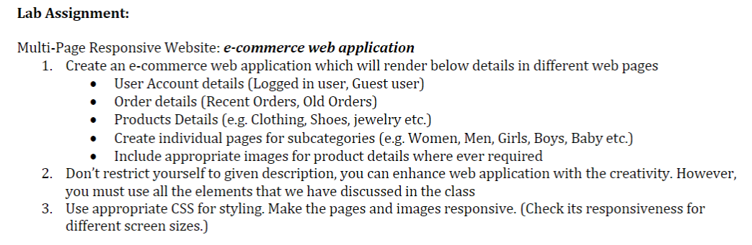
Solution:
Home Page:
Below is the screenshot of the home page of our e-commerce web application. It contains different categories for shopping, users can select the respective category and can navigate to the product details page
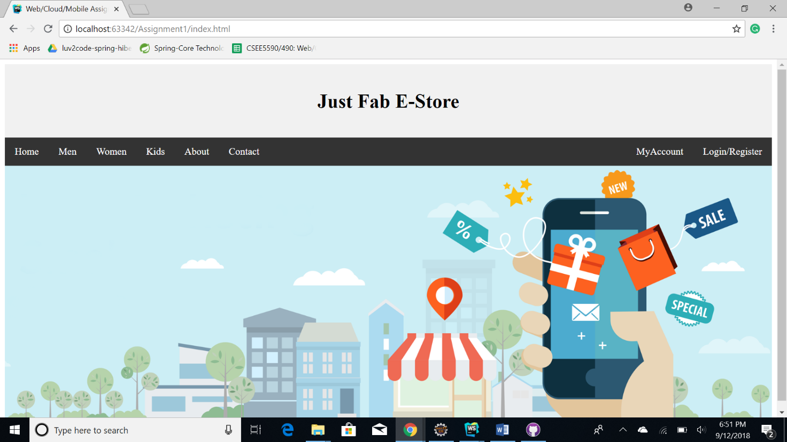

Login and Registration Pages:
The home page also contains the option to login into the user account by clicking the Login/Registration button. On clicking the login button users are redirected to login page where users should provide username and password.
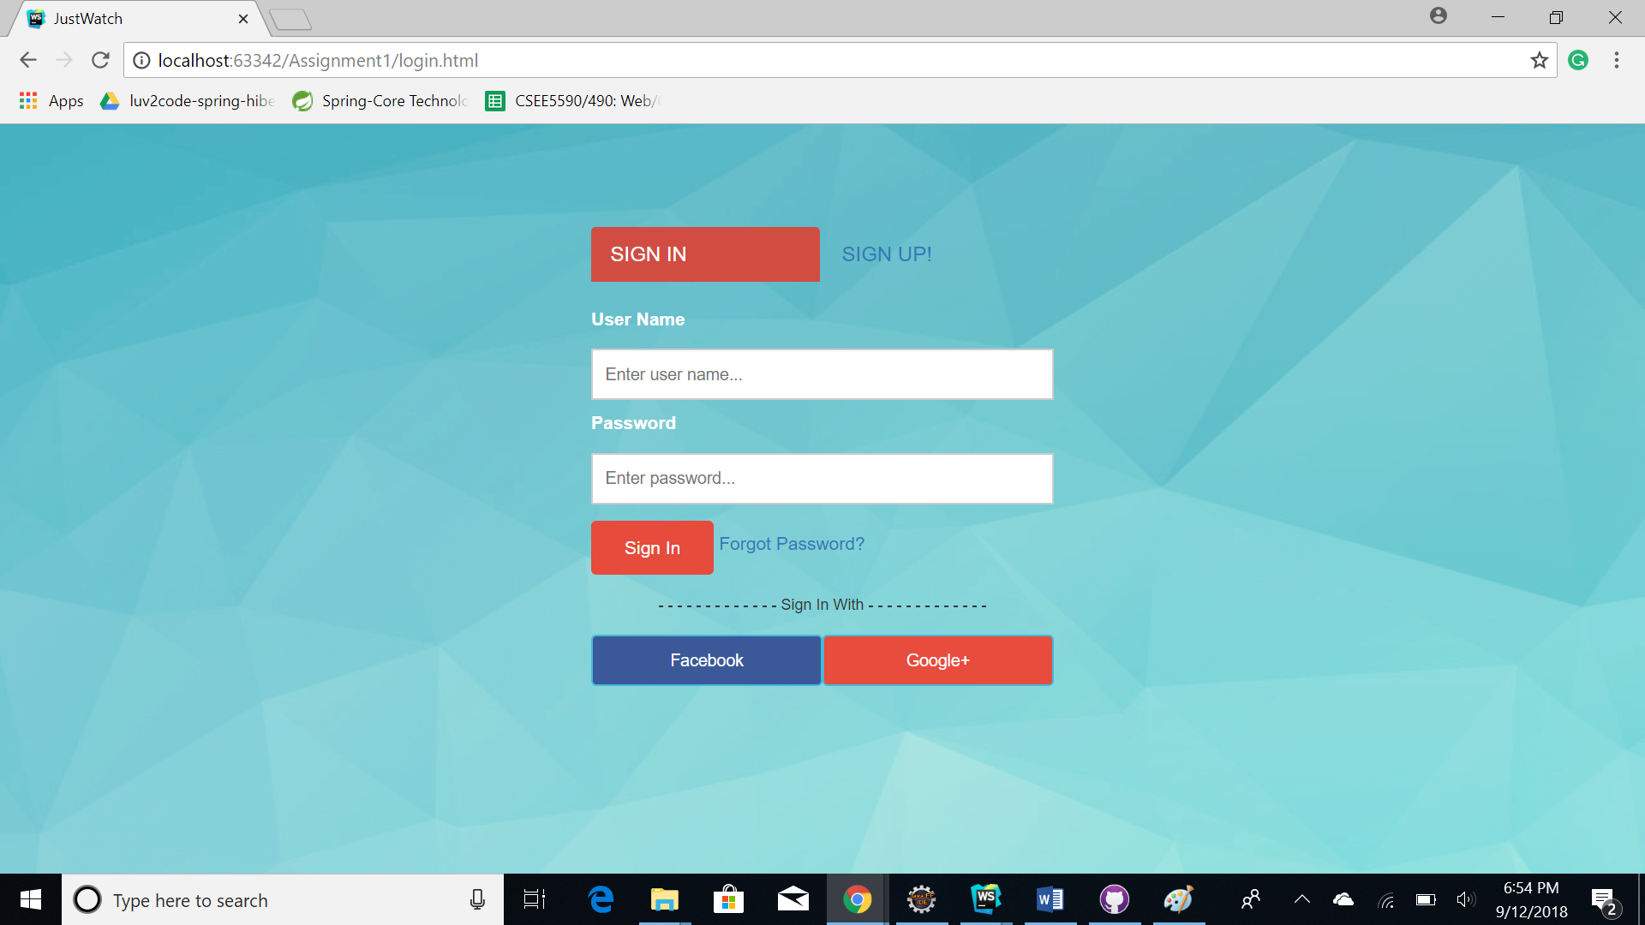

We implemented the validations for the login page. If the users try to login without providing all the details, a popup error message is displayed to the user.
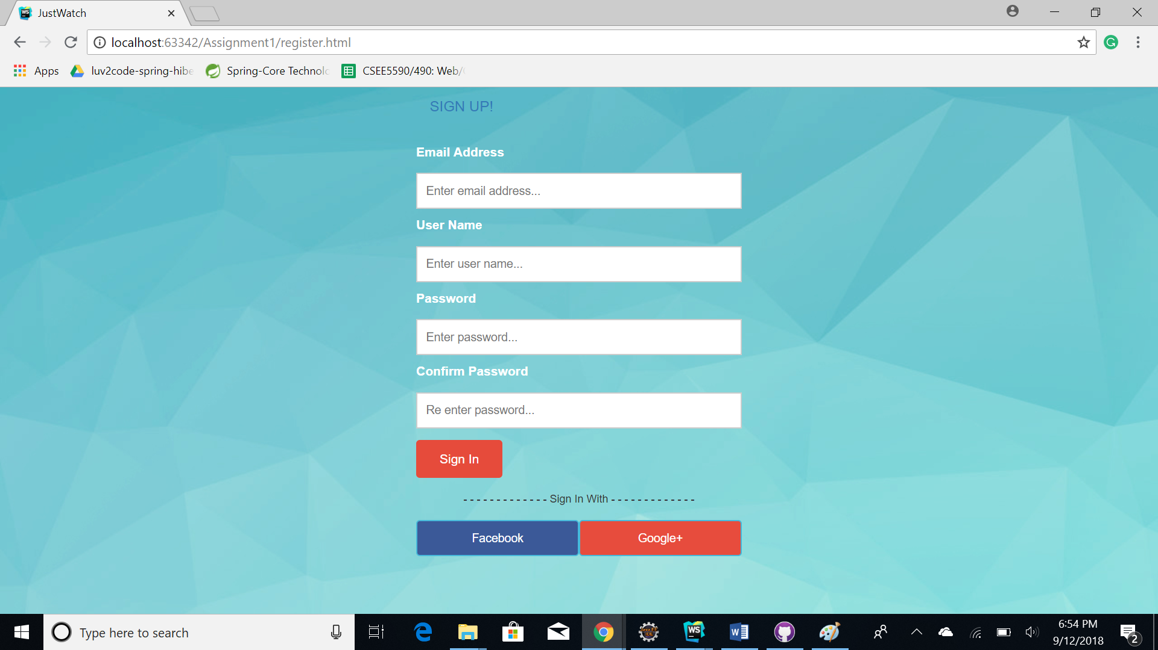

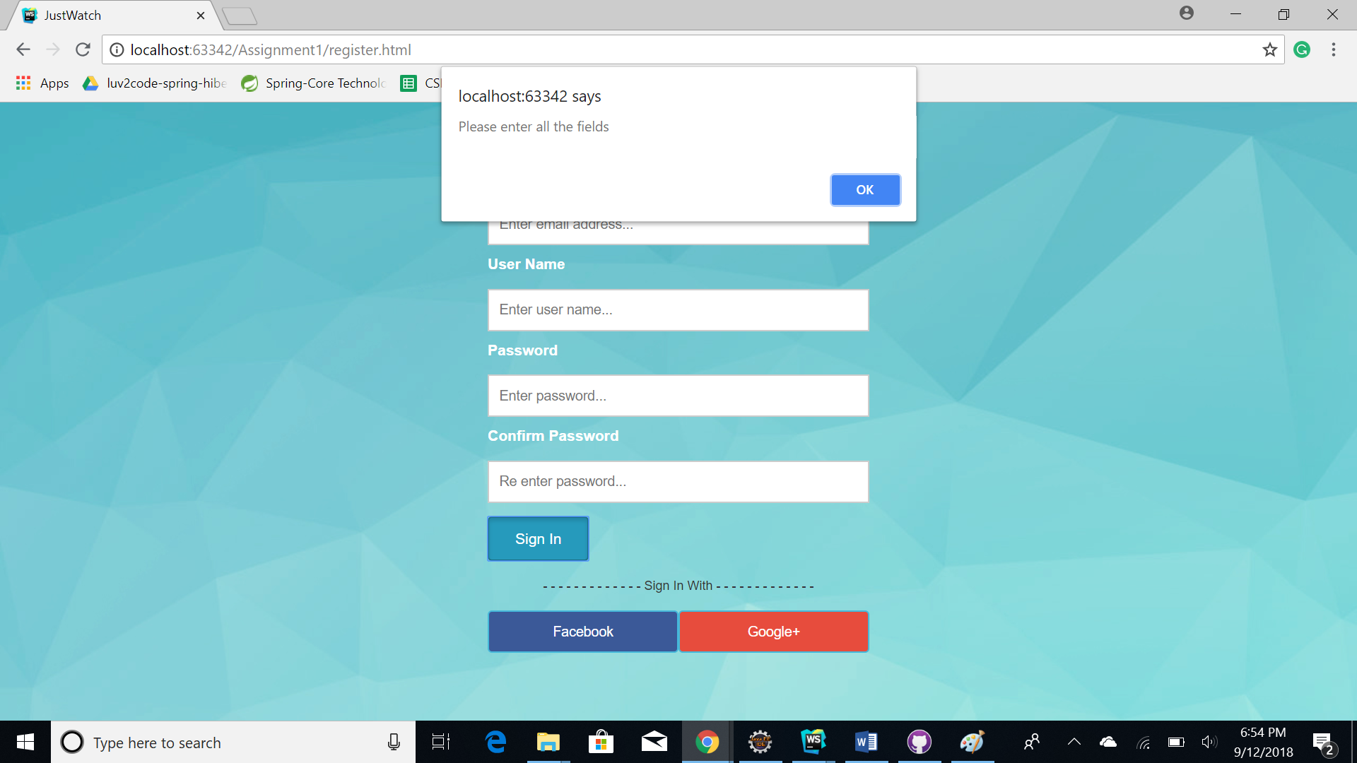

In home page if users select the particular category they are redirected to the products details page where users can select the items.

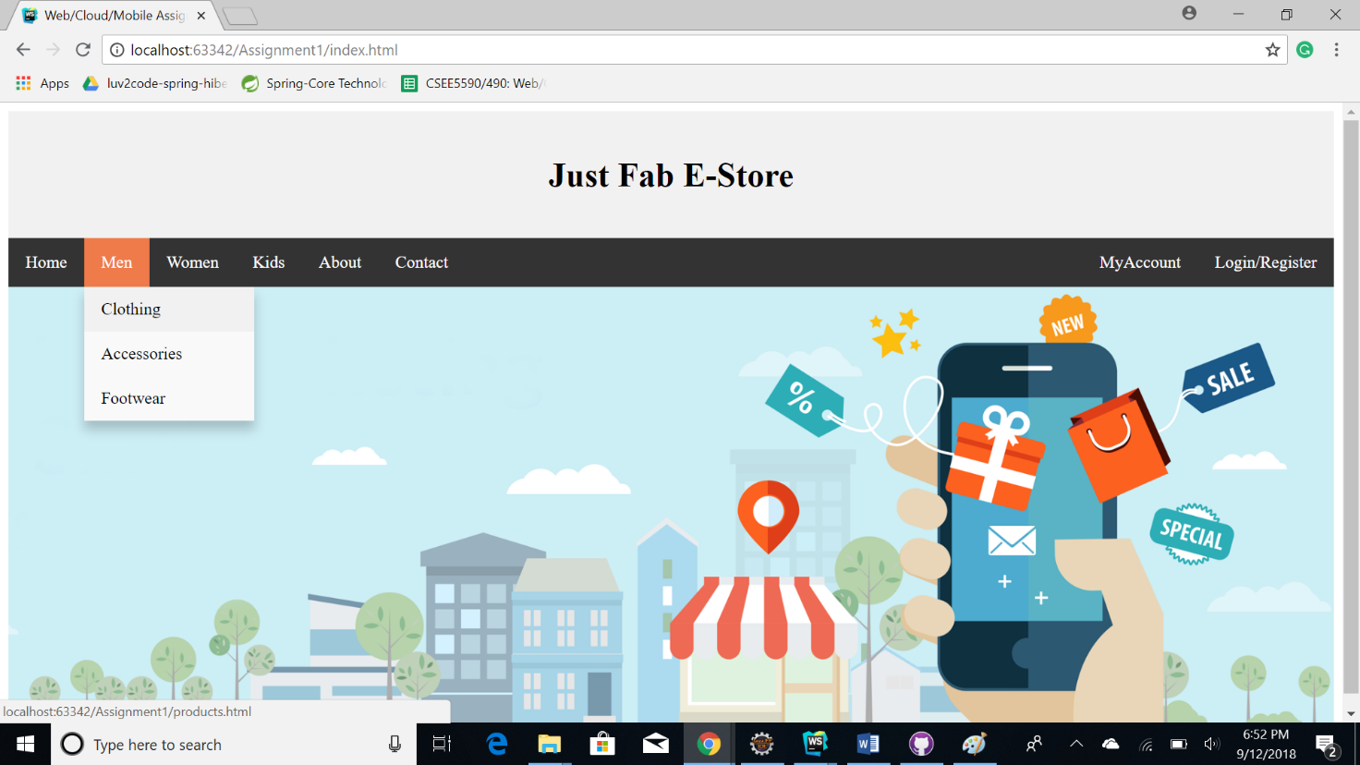

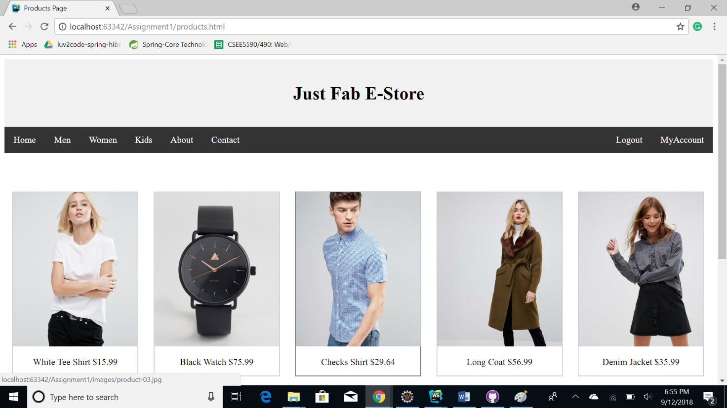

In home page users can view the recent orders by clicking on myAccount button and selecting the MyOrders option from the drop down. Below is the screenshot.

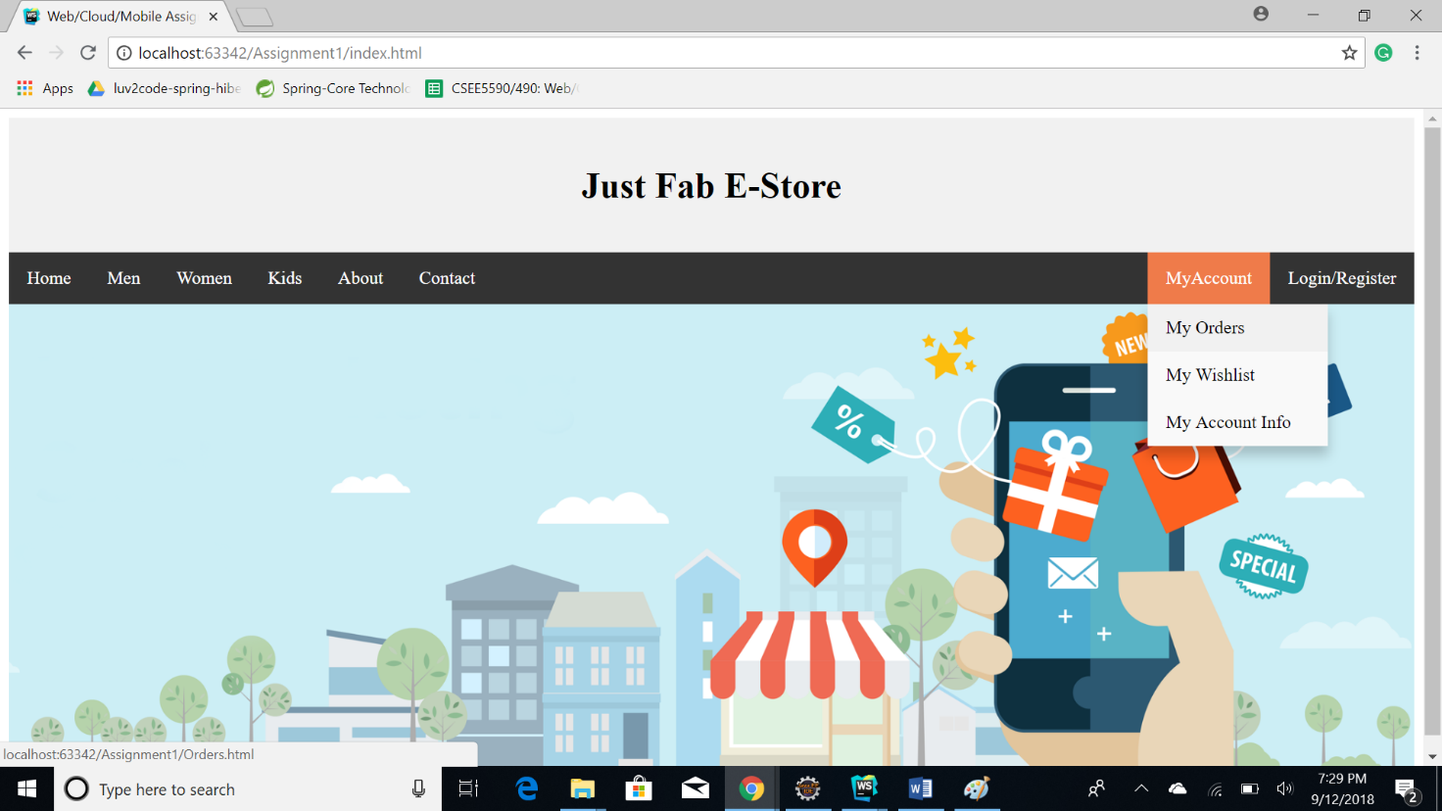

Recent order history

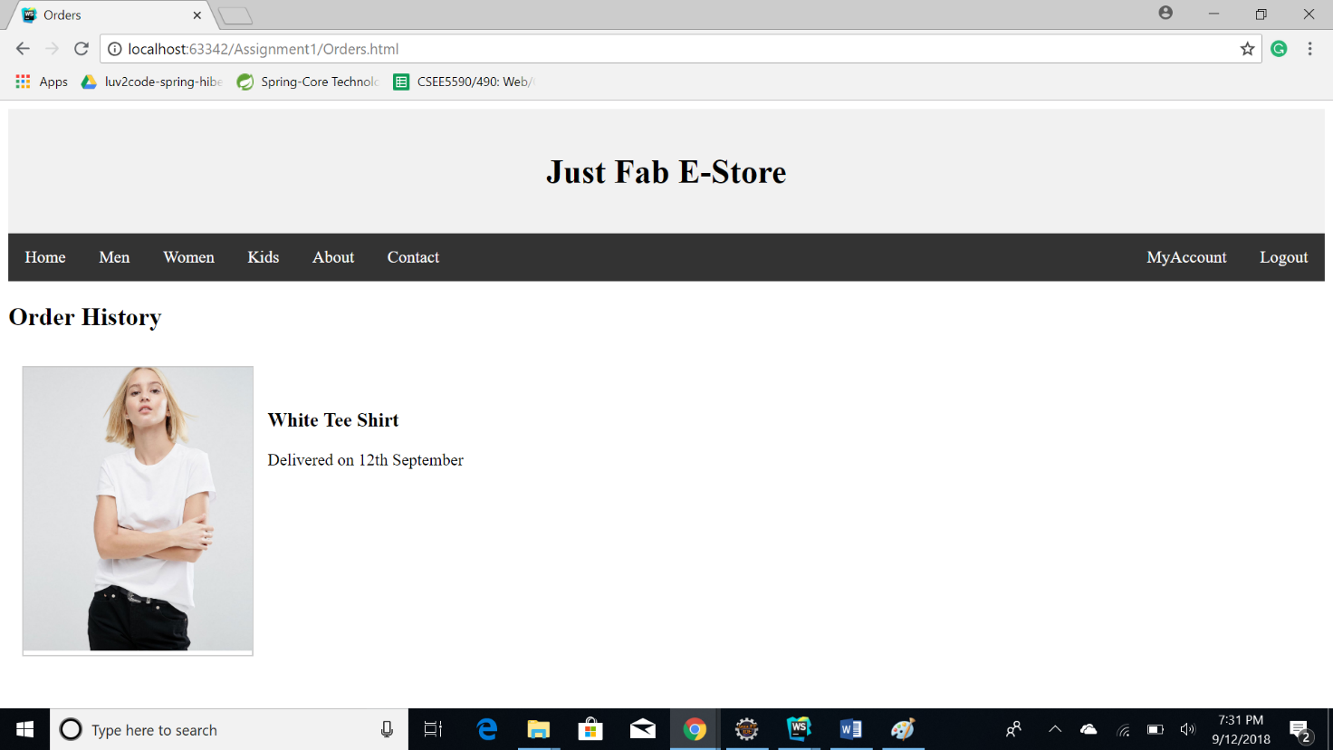

Responsive web design:

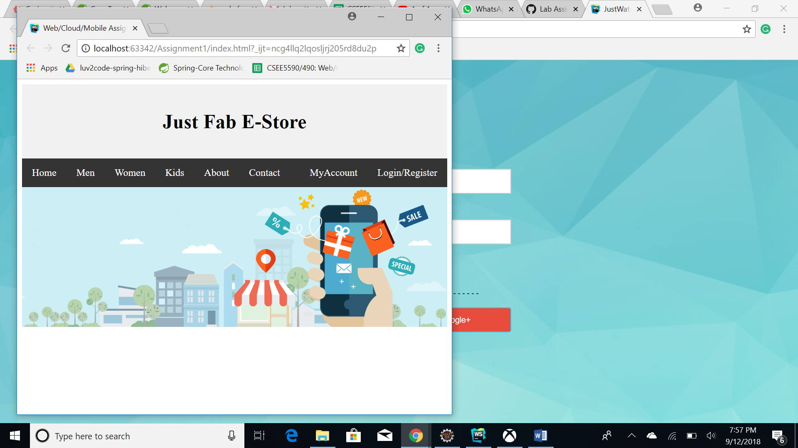

Conclusion:
As stated the above workflow with certain set of parameters is followed in solving the execution by implementing the core and basic concepts of the web programming.

Source code link: https://github.com/Sridevi333/Programming-web-cloud-mobile/tree/master/Assignments/Assignment%201

Video Link: https://youtu.be/tGjLFrq_zEQ

Wiki Link:
https://github.com/Sridevi333/Programming-web-cloud-mobile/wiki/Lab-Assignment-1

